Vermot-Desroches Matthias

Rapport de séance n°1

During this session, I decided to make sketches about the structure of our robot.

I started by doing a rough sketch of the global view:

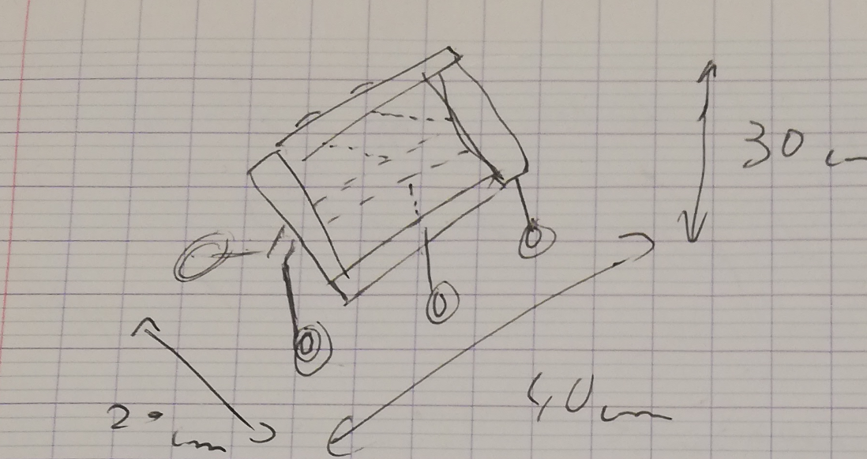

I indicated the maximum dimensions that we are allowed to use.

Then, I made a sketch of the front view:

In this sketch, I overlapped the suspension and the bar that would allow the wheels to move vertically. I also drew the body in a T-shape, at the top, there will be the LIDAR and the other captors. Inside, there will be the Arduino cards, the other microprocessors, and the alimentation.

To go further on this configuration, I drew a side view:

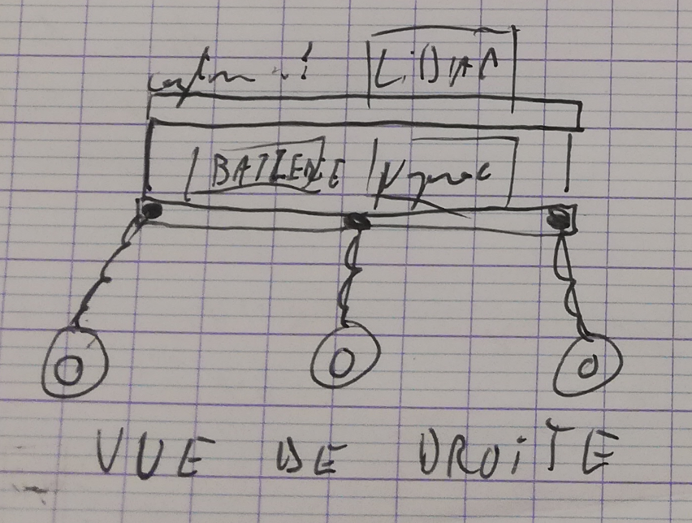

After that, I drew the shape of the aluminum (or any other material that we will choose) bar/plate that we will use to make the body of the robot, alongside a possible way to assemble two bars:

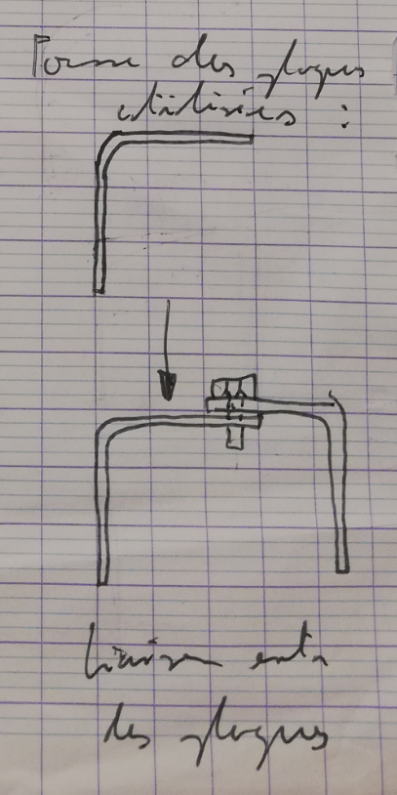

We wish to have L-shaped bar. A possible way to fix one bar to another would be to use a screw or maybe to wield them together. Another shape possible for the metal bar/plate would be a U-shaped plate.

Then, I chose to focus on the wheel + motor + servomotor group. I began by researching already existing group and comparing these researches with what we wanted to do:

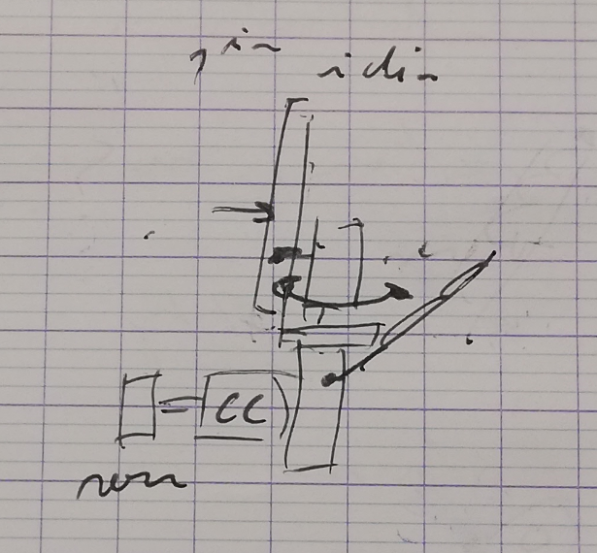

This is the first idea that I had. However, this solution can’t make the wheels rotates on themselves, thanks to the bar that we would use to fix the servomotor. Furthermore, the bar cannot allow the group to move vertically.  
After speaking to Mr. Masson about it, I drew another possible solution:

On this solution, the servomotor is on the bar and a little support allows use to link it with the suspension. The motor + wheel group is linked with it by using another support piece. The wheels can turn on themselves and the bar allow them to move vertically.

To continue this solution, I drew a sketch of the servomotor and the support piece:

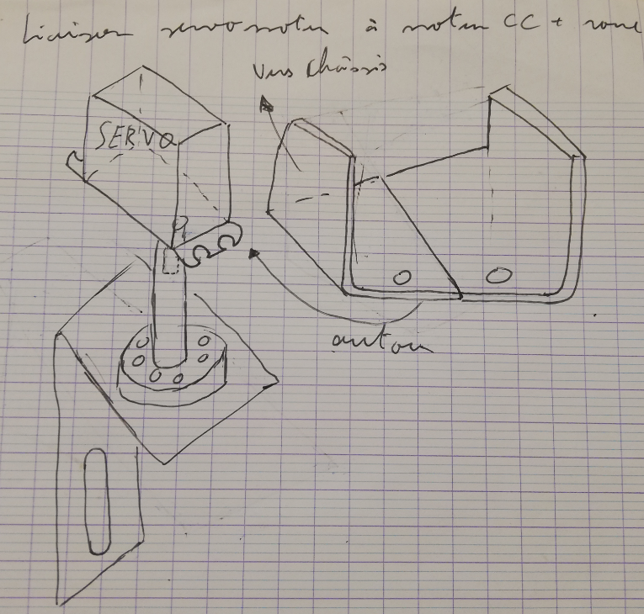

We can see that the servomotor will by on the metal bar (wielded or using a U-shape). The servomotor will rotate the wheel + motor group thanks to a shaft fixated on the support piece.

Afterward, I did a CAD model of a motor. However, after speaking with Mr. Masson again, I realized that is was not necessary (maybe useless) because we didn’t need to make a CAD model of the entire robot with every component, so I stopped doing it. Here is the little bit of CAD I did:

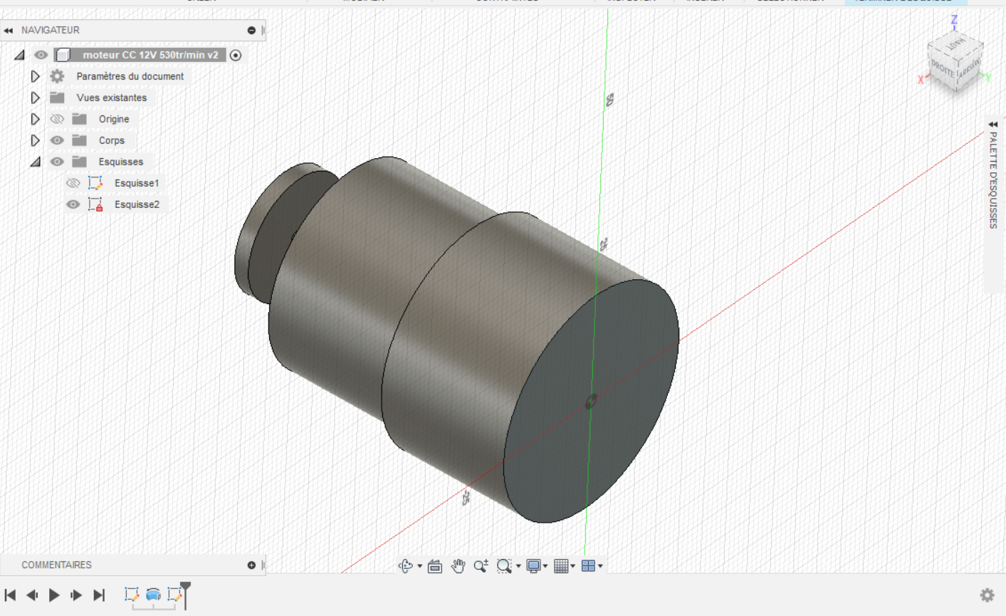

Before the end of this session, I was able to begin and almost finish the CAD model of the support piece shown above. Here is what I manage to do:

To finish this CAD, I need to make the piercing and maybe the threading for the screw hole.